Room BQuestion2
Intussusception (Reviewed by Dr. Longshore)
Stem: : 8-month-old male, otherwise healthy presenting about a week after an upper respiratory infection with 6 hours of intermittent crying and bringing his legs to his chest followed by vomiting. In between the episodes he acts normal and playful. Vital signs are within normal limits; he has no previous surgical or medical history. Physical exam demonstrates no evidence of inguinal or umbilical hernias, palpable mass in the right mid abdomen on abdominal exam, non-peritoneal.
KUB demonstrates dilated small bowel loops with air-fluid levels

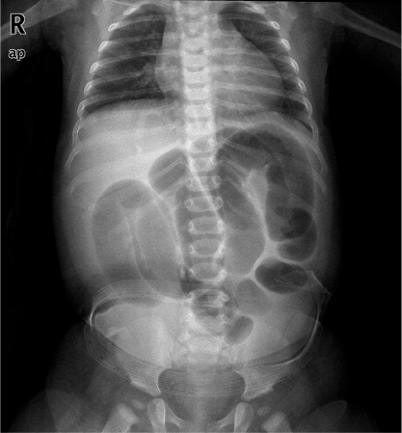

What is your Differential Diagnosis?
1. Intussusception
2. Constipation
3. Meckel’s diverticulitis
4.A ppendicitis Gastroenteritis
What additional Workup or Studies?
US of the right lower quadrant demonstrates a target sign suggestive of intussusception

What would you like to do now?

- IV access, 20 ml/kg bolus of NS
- Obtain an air-contrast enema for reduction of the intussusception

What If recurs?
- R epeat enema process.

What if unable to reduce the ileocecal intussusception with air contrast enema?

- OR for exploratory laparotomy through transverse RLQ incision (MIS laparoscopic option is acceptable)
  - Place NG tube
  - Milk the intussusceptum retrograde into the proximal bowel with slow constant squeezing,
(NOT only pull on the proximal bowel to reduce it)

Still unable to reduce? Resection with primary anastomosis

Scenario 2:Same patient with two days of intermittent pain, bloody-mucous stools, now with tachycardia, distention, and involuntary guarding on abdominal exam?
- OR for exploratory laparotomy.

